Practical 3: Car Booking Reservation System using Cloud Service Provider (SaaS)
Aim
To create a simple cloud-based Car Booking Reservation System using a Cloud Service Provider to demonstrate the Software as a Service (SaaS) model.
Procedure
- Sign in to the selected Cloud Service Provider.
- Create a new application.
- Design a reservation form containing Customer Name, Car Model, Pickup Location, Drop Location, Booking Date, Duration, Contact Number, and Payment Status.
- Store booking details in the cloud database.
- Enable features for creating, updating, deleting, and viewing reservations.
- Test the application using sample booking records.
- Verify that data is synchronized and accessible online.
- Publish the application for cloud access.
Implementation
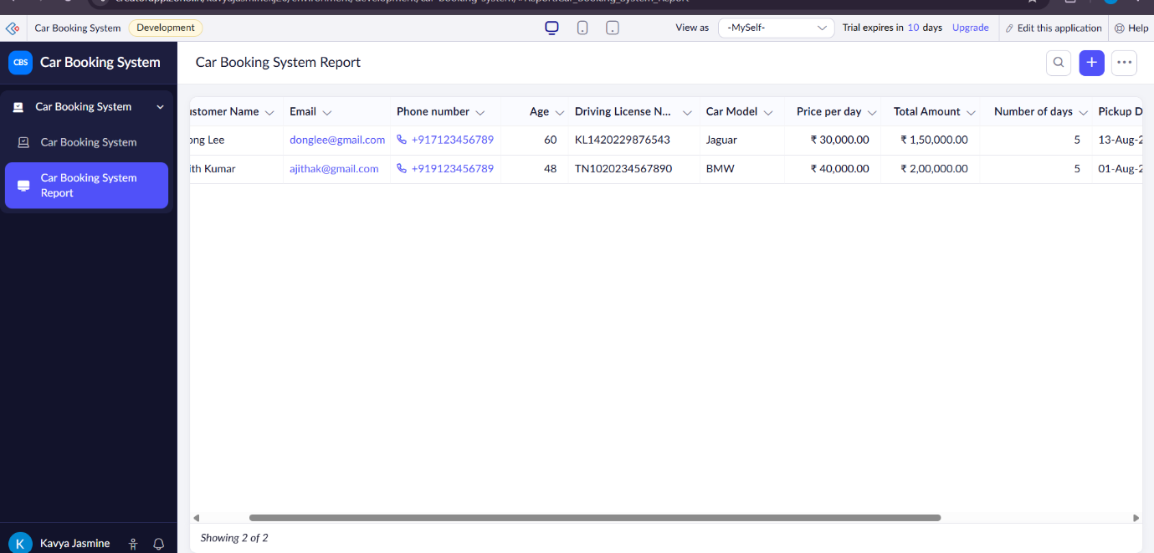
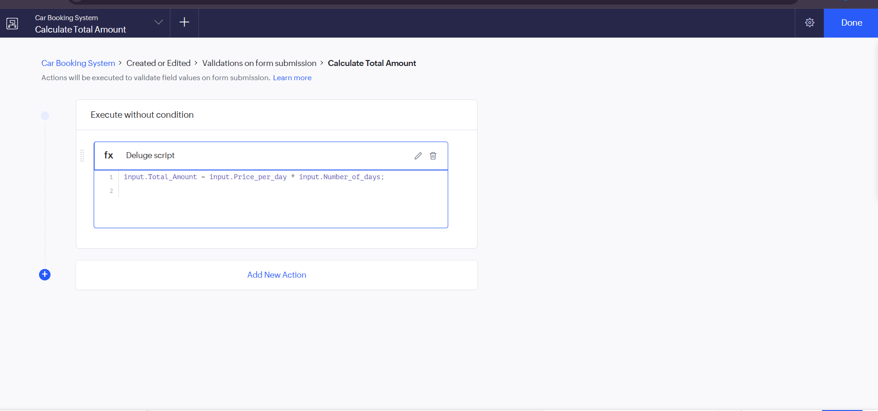
Result:
The Car Booking Reservation System was successfully created using Zoho Creator as a cloud-based SaaS application. It enables users to book cars online, stores booking details in the cloud, and provides easy access and management of reservations. The objective was achieved successfully.

